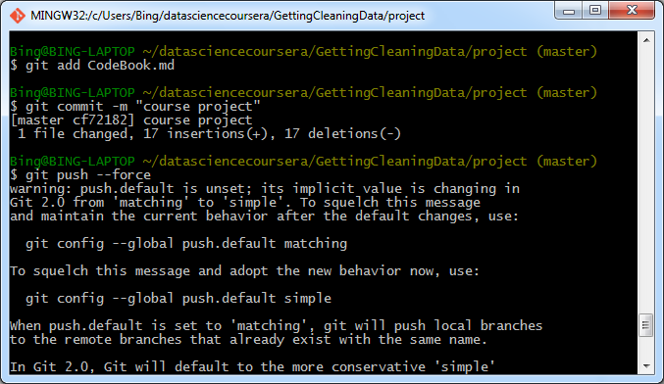

If the red stuff happens (in the screen shot below), use git commit –am “xxxxx” (i.e., add –a in front of m)

